ISDN-PRI VFO Fields

Below are the fields specific to ISDN-PRI. All other fields on the LSR will require the same information as any other LSR.

Field | Detail | Valid Entry
REQTYP | Request Type | QB
TOS | Type of Service | 1KF-  2 (RES) is not offered.
NC/NCI/SECNCI | Service Type | Not required
REMARKS | Additional information | Anything without its own field below.
P | Service Platform | A - Resale

IS_ADMIN Section
Field | Detail | Valid Entry
IQTY | ISDN Quantity – the number of ISDN-PRI’s desired | 01, 02, etc.

IS_SVC_DET Section
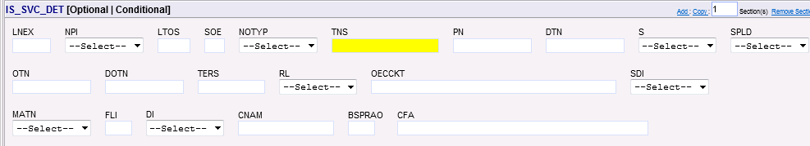
Field | Detail | Valid Entry
NOTYP | Number Type | A = ISDN-PRI
TNS | Telephone Numbers – Existing DID/BTN to point to the PRI  -New DID/BTN requested | 10 digit TN, ex: 9195552222  N – for New TN | Desired pilot
CFA | Circuit Facility Assignment | If provided, this must be a valid CFA. This is not required for a Resale ISDN-PRI.

SVC_DET_GRP Section
Field | Detail | Valid Entry
LOCNUM | Location Number | 01
LNUM | Line Number | 01, 02, etc
LNA | Line Activity | C, D, N, P, T, V, W
ECCKT | Circuit ID | Existing circuit ID  N – for new circuit ID

LINE_RESTRICT_2 Section
Field | Detail | Valid Entry
FPI | Freeze PIC Indicator | A = Freeze LPIC  B = Freeze LPIC/PIC  E = Freeze PIC  R = Remove PIC freeze  S = Remove LPIC freeze  T = Remove LPIC/PIC freeze
PIC | InterLATA Pre-subscription Indicator Code | Valid PIC code
LPIC | IntraLATA Pre-subscription Indicator Code | Valid PIC code

SVC_TERM_DET Section
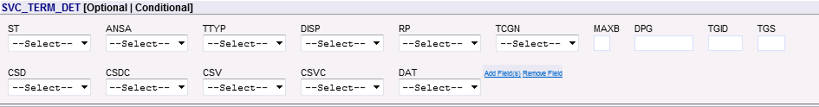
Field | Detail | Valid Entry
ST | Cust Switch Type | 1 and 2 are the most common.  1 = 5ESS  2 = DMS  3 = EWSD  4 = Other switch type  5 = GTD5-EAX

SVC ISDN DET Section
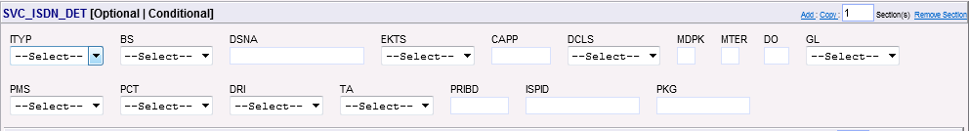
Important Note: This section must be included for each ISDN-PRI requested.

Field | Detail | Valid Entry
ITYP | ISDN Type | A = Custom  B = National ISDN-1 (NI1)  C = National ISDN-2 (NI2)  D = National ISDN-3 (NI3) | CUSTOM OR NATIONAL
EKTS | Electronic Key Telephone Set | A = Basic  B = Call Appearance Call Handling (CACH) | Required when ITYP field is B, C, or D.
DO | Digits Out | 2 digits, ex: 10. Required on ACT N, optional on all others | NBR DIGITS SENT
GL | Yield to Glare | A = End user switch  B = NSP-switch  C = No change  *C is only valid on ACT C or V
PMS | Primary Rate Method/Hunt Sequence | A = Low to high  B = High to low  C = Most idle  D = Least idle  E = Clockwise circular  F = Counter clockwise circular  *If E or F are chosen, an additional Price Plan must be added as there are additional charges for Circular hunt. | HUNT SEQUENCE
PCT | PRI Call Type | A = Inward  B = Outward  C = 2-way
PRIDB | PRI B & D Channel Configuration – ISDN-PRI offers 24 channels. Primary PRI requires at least one D channel, additional secondary PRI’s may use NFAS to link together and may have zero D channels. | Ex: 012301Y, 022400Y  Characters one and two  Sequentially populated starting with 01 – should match LNUM.  Characters three and four  01 through 24 – identifies the number of B Channels desired.  Characters five and six  00 through 02 – identifies the number of D Channels desired.  *This can only be 00 if this is a secondary PRI and the primary is marked Y for NFAS.  Character seven  Y = NFAS N = No NFAS

FEATURE_GRP Section
Field | Detail | Valid Entry
FA | Feature Activity | Valid Price plans from Available Services. | CALL BLOCK, TOLL BLOCK,  BACKUP D CHNL ASGNMT, etc

