**Brightspeed**

**EASE / VFO User ID**

**Administration Guide**

Contents

I. EASE / Virtual Front Office (VFO) Login 1

II. EASE / Virtual Front Office (VFO) New User Setup 7

III. EASE / Virtual Front Office (VFO) Password Resets 14

IV. EASE / Virtual Front Office (VFO) User Name Deletions 15

V. EASE / Virtual Front Office (VFO) Logout 17

VI. EASE / Virtual Front Office (VFO) Contact Information 19

## I. EASE / Virtual Front Office (VFO) Login

Access EASE by typing “https://ease.brightspeed.com/” in your internet browser. The EASE home page will be displayed.

For ASR access, click on the “VFO” tab, select “ASR” and click on the link for “Virtual Front Office (ASR)”.

For LSR access, click on the “VFO” tab, select “LSR” and click on the link for “Virtual Front Office (LSR)”.

You will be directed to the “Virtual Front Office” login page. Enter your “User Name” and “Password” information, click on the “Change Password” box, then click on the “Login” button.

You will be prompted to change your password. After inputting the required info, click on the “Update Password” button.

Password Rules

Customer users can change their own passwords, using the following rules:

Passwords chosen **must**:

* Be at least 8 characters in length but not more than 16 characters
* Contain at least one character from any three of the following four categories
  + Uppercase alphabets (A-Z)
  + Lowercase alphabets (a-z)
  + Numbers (0-9)
  + Special characters (~ ` ! @ # $ % ^ & * ( ) - _ = + { } [ ] \ | ; : ‘ “ , . < > / ?)

Passwords chosen **must not**:

* contain a space
* be "password" itself (case insensitive)
* be same as the login user name
* be the same as the 5 previously saved passwords

You will be returned to the Virtual Front Office login page, where you will receive verification that your password has been successfully updated. Once again, enter your “User Name” and “Password” information, and then click on the “Login” button:

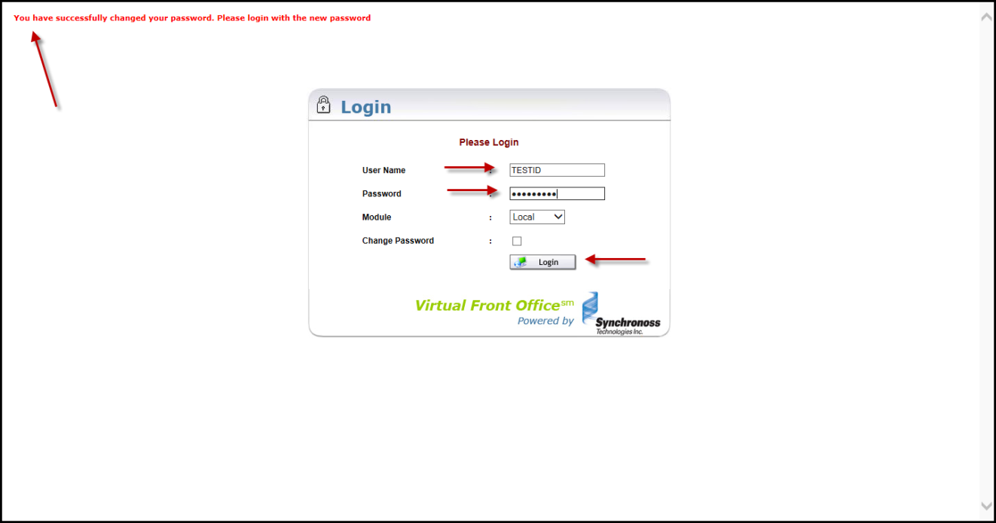

## II. EASE / Virtual Front Office (VFO) New User Setup

You will be directed to the VFO Home Page. To proceed to User ID Administration Section, roll your mouse cursor over the “Administration” tab at the top of the page and you will see a “Security” option appear underneath the “Administration” tab. Click on “Security” option.

Click on the “User Profile” link.

To setup a new User, click on “New” button, located at upper right-hand corner of your screen.

Fill out the following fields:

* **User Name** (minimum length 6 characters, maximum length 30 characters; User Name should not be SSN-based or contain 3 alpha characters followed by 4 numeric characters; no special characters are allowed; however, A – Z and 0-9 are acceptable). You can verify if a user name already exists by entering the id and clicking **GO** to search for the id. If found, you can click on the id to edit the entry.
* **Password (**enter a unique password which should be at least 8 characters in length. Please note that this unique password is to be utilized by the new user when he/she logs in via EASE for the first time.)
* **Confirm Password** (enter same unique password previously entered in “Password” field)
* **Full Name** (User’s First and Last Name)
* **Designation** (leave blank)
* **Locked** (check box – leave blank unless resetting access to an existing account that is locked due to failed login attempts)
* **Active** (check box – check when resetting password)
* **Password Never Expires** (check box – leave blank)
* **Allow Submit with Errors** (check box – leave blank; functionality only permitted for internal CenturyLink users)
* **User Type** (using drop down, select “ESP”)
* **ESP Name** (this field will be pre-populated with your company’s primary CCNA (for ASR) or OCN (for LSR), known as an ESP in VFO)
* **Phone** (input user’s telephone number, including the area code, WITHOUT dashes; e.g. 9999999999)
* **Email ID** (input user’s email address)

The fields below are optional and will auto populate the associated fields in the PON.

Additional Information

* **Fax**
* **Street Address**
* **Floor**
* **Room/Mail Stop**
* **City**
* **State**
* **Zip/Postal Code**
* **Implementation Contact**
* **Implementation Contact Phone**
* **Alternate Implementation Contact**
* **Alternate Implementation Contact Phone**
* **Design Contact**
* **Design Routing Code**
* **Design Contact Phone**
* **Design Contact Fax**

**Save**

*The assignment of User Names in the VFO System is global. Duplicate User Names are not permitted. Please ensure that the User Names that are assigned to your User Group(s) are unique.

**Select Group** – The Group identifies the role the user will be performing; e.g. User or Admin. Highlight a Group name underneath “Available” box to designate as the user’s Primary Group. Click the right arrow located to the left of the Primary Group box and the group name will be populated in the Primary Group box. Only one Primary Group is allowed per user.

**Select Group, cont’d** - If a user requires access to an additional group, highlight additional group name and click on right arrow to the left of the Secondary Group box, placing the additional group in the Secondary Group box.

*Note: Use the LSR_PREORDER option if that is the only role user will perform (e.g. will not be submitting orders, just preorders). The LSR_USER profile allows users to submit preorders and orders; do not use both.*

When finished completing all required fields of User Profile, click on the “save” button, located at top User Profile screen.

New User Name will appear under the User Profile Search List.

***\*\*\* Please note that NEW USER access will take effect immediately. \*\*\****

If additional User Names need to be setup, click the “New” button, located in upper right-hand corner of screen and follow previous instructions.

## III. EASE / Virtual Front Office (VFO) Password Resets

After navigating to the Administration Tab and selecting the Security Tab, click the User Profile link to search for a user.

Enter the User Name you are searching for. You can also search by Group Name the user belongs to.

You can use the % wildcard search if you don’t know the user name. *Example: a% would return all the users with “a” at the beginning of their user name.*

To reset a User’s access, click on the User Name you wish to reset.

User’s Profile information will be displayed. Click inside the “Password” and “Confirm Password” fields. Enter the same unique password, which should be at least 8 characters in length, in each field. If the user’s account is locked due to failed login attempts you will need to uncheck *Locked*. Click on “Save” button.

## IV. EASE / Virtual Front Office (VFO) User Name Deletions

After navigating to the Administration Tab and selecting the Security Tab, click the User Profile link to search for a user. To Delete a User’s access, click on the User Name you wish to delete.

User Profile information will be displayed. Click on the “Delete” button, located at upper right-hand corner of page.

A pop-up box will appear (“Are you sure you want to delete the record?”). Click on “OK” button.

Upon successful deletion of record, the message “There are no User’s to show for the selected filter criteria.” will be displayed.

## V. EASE / Virtual Front Office (VFO) Logout

To exit VFO, click on “Back to Home” button, located at upper right-hand side of page.

Click on “Close” button, located at upper right-hand side of page.

Click on “Logout” button, located at upper-right hand corner of page.

VI. EASE / Virtual Front Office (VFO) Contact Information

Please note that you will only be able to view your company-specific orders and not those of other IXCs or CLECs.

For additional assistance with User ID management, please contact the Brightspeed IT Helpdesk 833-965-1633.