October 2022

EASE VFO Preorder

Address Validation – Telephone Number Inquiry – Customer Service Information – Loop Qualification – Raw Loop Data – Listings for Telephone Number

Table of Contents

EASE VFO Preorder 1
New Preorder 3
Preorder Initiation 4
Address Validation 5
Address Validation Results 6
Telephone Number Inquiry 8
Telephone Number Inquiry Results by Specific Numbers 10
Telephone Number Inquiry Results by New Random Number 10
Telephone Number Inquiry Results by Range of Numbers 11
Telephone Number Inquiry Results by Sequential Numbers 11
Cancel Previously Reserved Numbers 12
Customer Service Information 13
Customer Service Information Results 15
Loop Qualification 17
Loop Qualification Results by Address 19
Loop Qualification Results by Telephone Number 20
Raw Loop Data 21
Raw Loop Data Results by Telephone Number 23
Raw Loop Data Results by Service Address 24
Raw Loop Data Results by Circuit 26
Listings for Telephone Number 28
Listings for Telephone Number Results by Caption 29
Listings for Telephone Number Results by LTN 30
Save and Search 31
Service Address Glossary 35

EASE Preorder

New Preorder | Preorder is an option that provides address validation, telephone number inquiry, customer service information, loop qualification, raw loop data and listings for telephone number.  To help insure order accuracy, address validation may be required when submitting certain order types. Address validation can be accomplished by:  - Selecting New from the Preorder tab drop-down menu  - Clicking the Validate link located in the SVC ADDR GRP section on the EU form of the LSR while entering an order.  - Clicking the Search Pre-Order link located in the SVC ADDR GRP section on the EU form of the LSR while entering an order. This functionality is using saved Preorders which is discussed further in this document.

Preorder—Preorder tab
Preorder— Validate link within the order 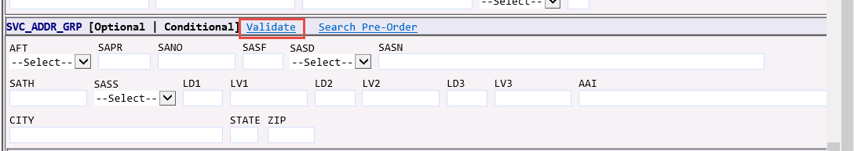
Preorder— Search Pre-Order link within the order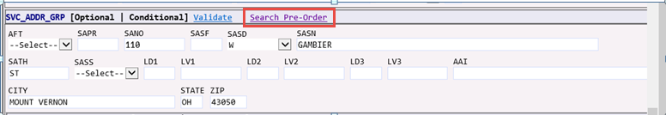
Note: When validating the address within the order – you will receive one of the following messages:
a) Exact address match or b) multiple addresses that contain additional information or c) no address match found or d) Qwest address. If multiple addresses are found, you may select the correct one and the additional fields on the LSR will auto-populate. If no match is found or Qwest address, you will need to research or correct the address.

Preorder Entry

Preorder Initiation | - With the Order List in view, roll your cursor over the Preorder tab and select New from the drop-down menu.  Result: The Preorder Initiation screen appears.  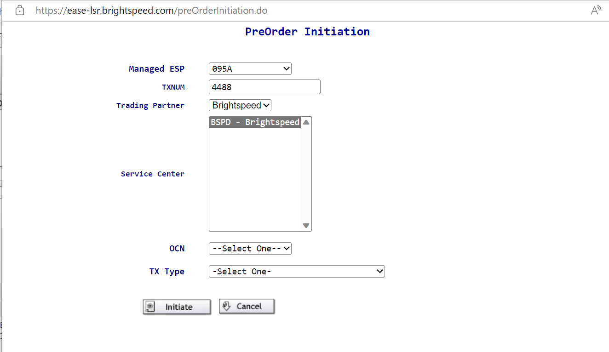  - Type a tracking ID in the TXNUM field or use the pre-populated ID.  Recommendation: Use the PON that will be utilized on the LSR.  Note: This can be up to twenty-five alpha, numeric, or alpha-numeric characters.  - Select EMBARQ from the drop-down menu of the Trading Partner field if necessary.  Note: No action is necessary in the Service Center field as it pre-populated.  - Select appropriate OCN from drop down menu.  - Available options from the TX TYPE drop-down menu.  A = Address Validation  B = Telephone Number Inquiry  E = Customer Service Information  H = Loop Qualification  R = Raw Loop Data  T = Listings for Telephone Number
 | - Click Initiate.

Address Validation

Address Validation Entry | After the Preorder Initiation screen populate the following fields.  TXACT - A = New Inquiry  STATE - two alpha characters (capital letters)  SVC_ADDR_GRP  - SANO = Service Address Number  - SASN = Service Address Street Name  - SATH = Service Address Street Type  - CITY  - STATE (two alpha characters – capital letters)  - ZIP  - Submit  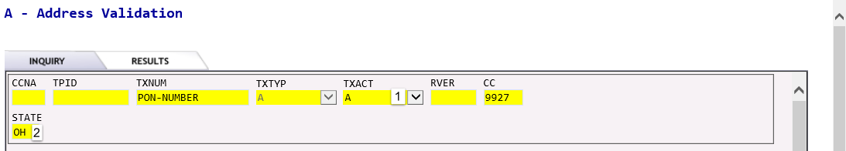  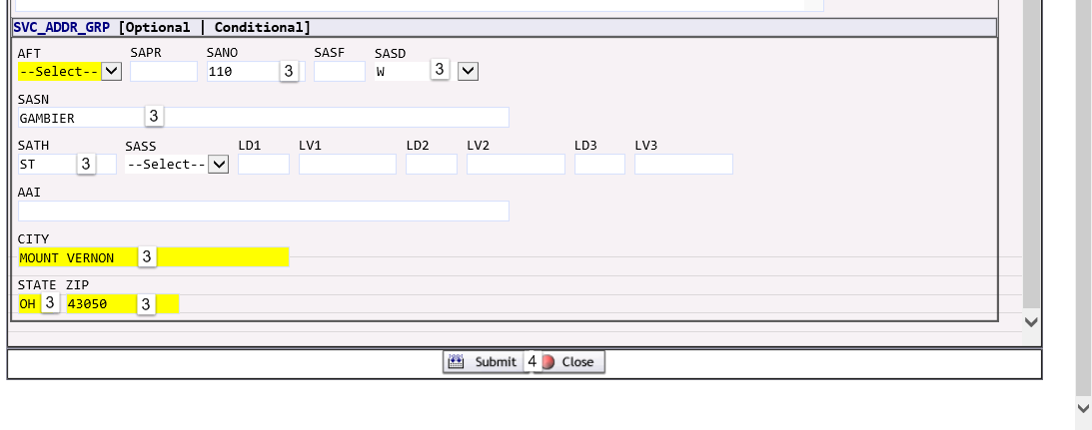  Note: For additional address fields see Service Address Glossary. Supplemental address information such as unit, bldg, etc. may be entered in either the LD/LV or the AAI fields.

Address Validation Results, cont. | Results and responses:  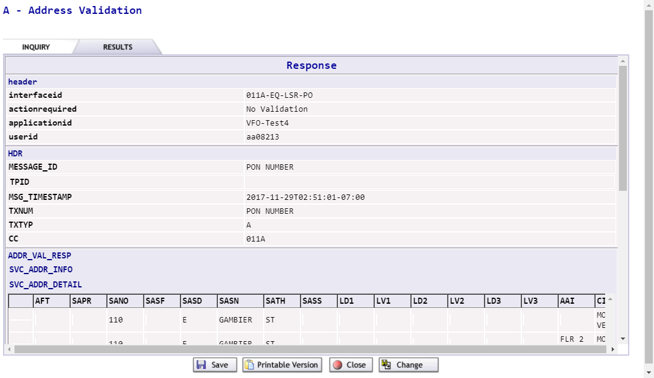  Address Near Match Found  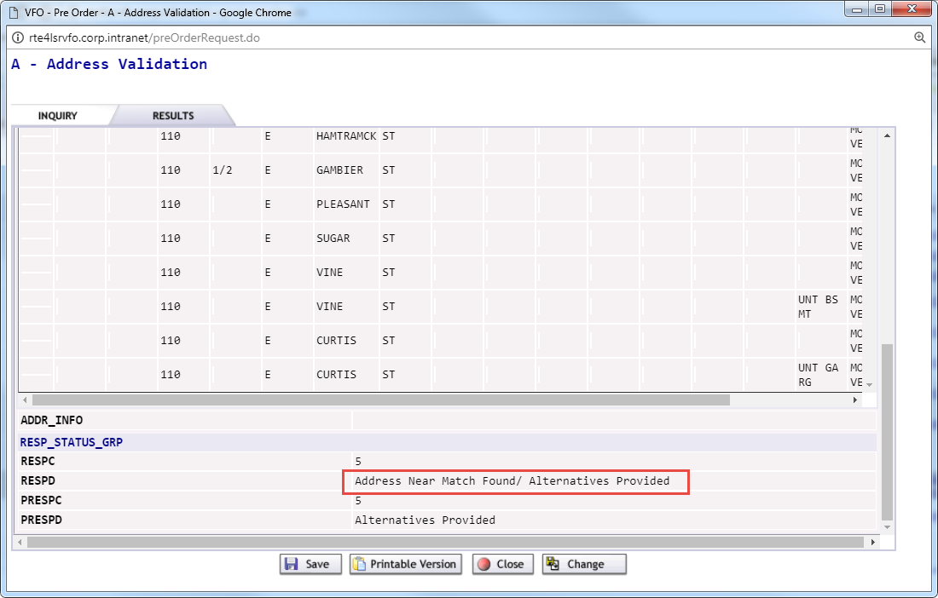  Exact Address Match Found  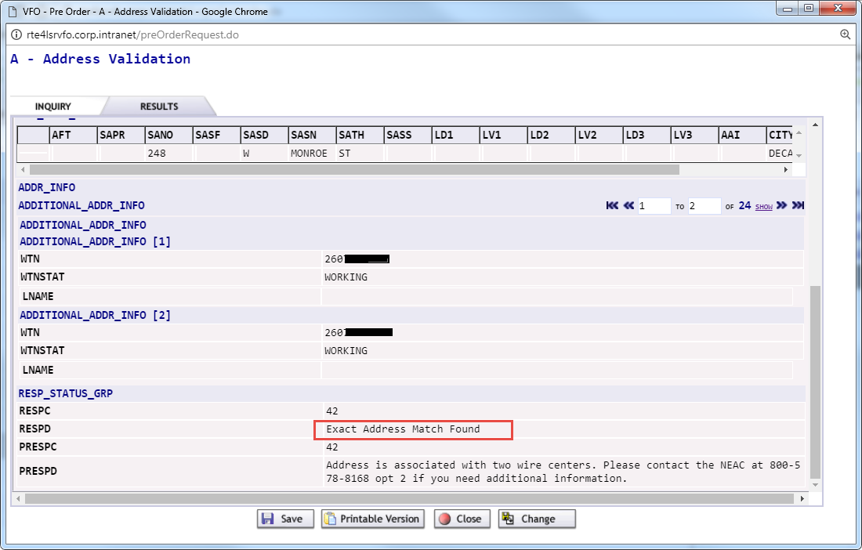

Address Validation Results, cont. | Results and responses, cont.:  Address Not Found  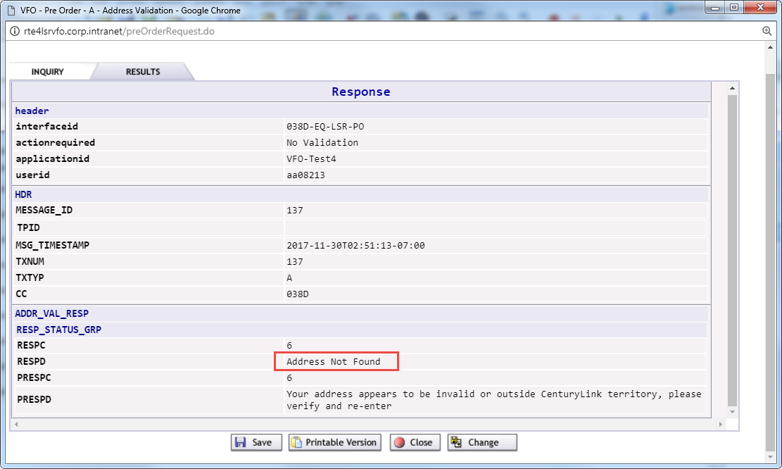  Exact Address Match Found – Qwest Market  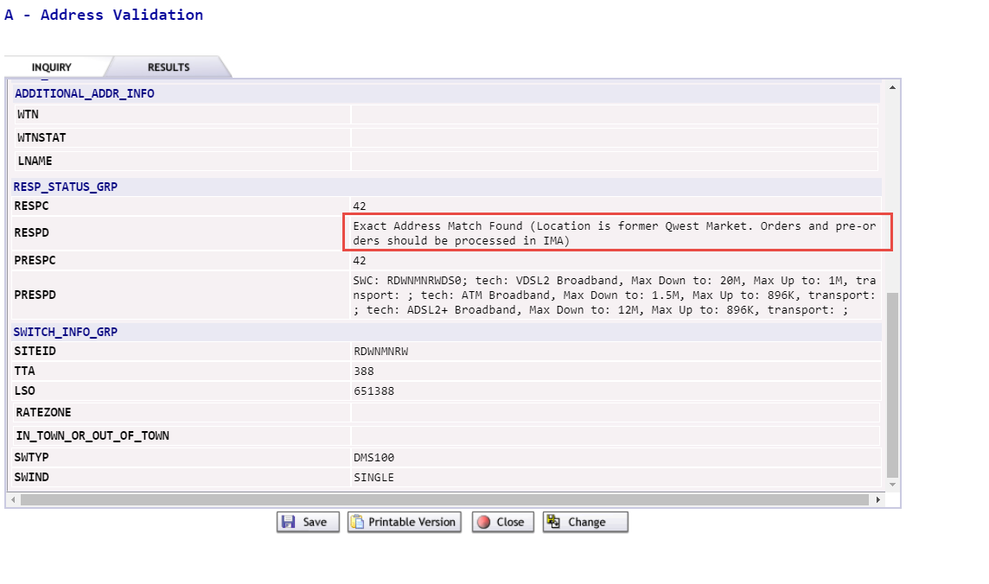  - Able to Save / Print / Close / Change the inquiry.

Telephone Number Inquiry

Telephone Number Inquiry Entry | After the Preorder Initiation screen populate the following fields.  TXACT - A = New Inquiry  STATE – two alpha characters (capital letters)  TOS = Type Of Service  LCS = Local Calling Scope (A = Local Service - Default), optional  QR = Quantity Requested (10 is maximum amount), optional  TNTYP  Options:  D = Specific Numbers  N = New Random Number  R = Range of Numbers  S = Sequential Numbers  LSO = Local Service Office - Preferred NPA / NXX for telephone number(s) requested. (Optional)  REQNUM = Requested Number - enter telephone number(s), or range of telephone numbers requested. (Optional)  When TNTYP is D = Specific Numbers (Ex: 7403921437)  When TNTYP is N = New Random Number (leave blank)  When TNTYP is R = Range of Numbers (Ex: 7403929714-9718)  When TNTYP is S = Sequential Numbers (leave blank)

Telephone Number Inquiry Entry, cont. | SVC_ADDR_GRP  - SANO = Service Address Number  - SASN = Service Address Street Name  - SATH = Service Address Street Type  - CITY  - STATE (two alpha characters – upper case)  - ZIP  Submit  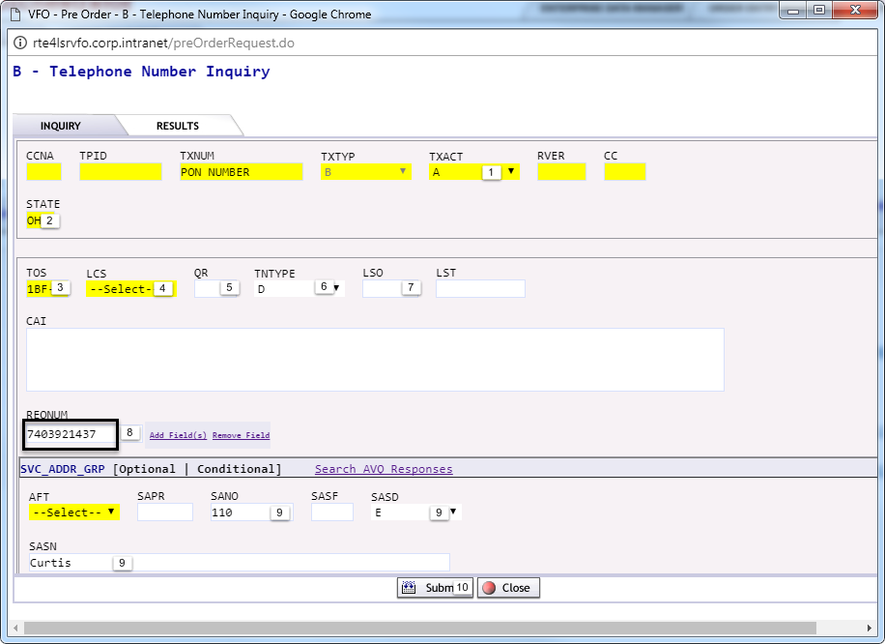

Telephone Number Inquiry Results, cont. | Results and responses:  Specific Numbers  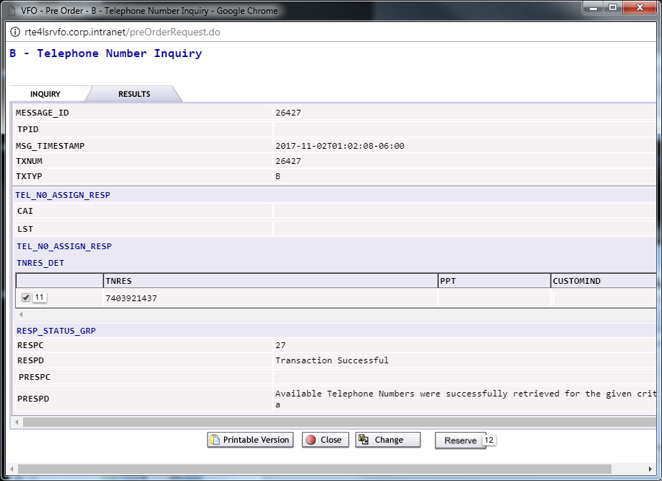  - Select Number  - Reserve  Note: If number is not selected or reserved in 20 minutes, it will return to the number pool.  New Random Number  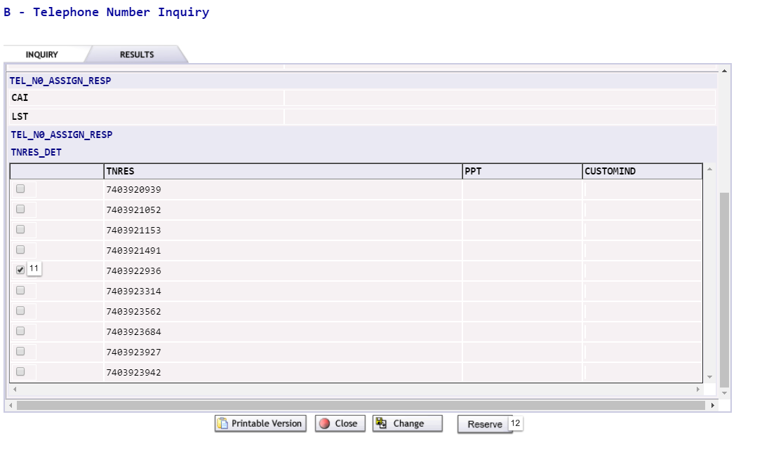  Select Number  Reserve  Note: If number or numbers are not reserved in 20 minutes, they will return to the number pool.

Telephone Number Inquiry Results, cont. | Results and responses, cont.:  Range of Numbers  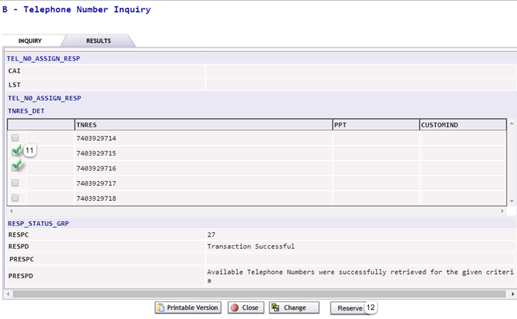  Select Number  Reserve  Note: If numbers are not reserved in 20 minutes, they will return to the number pool.  Sequential Numbers  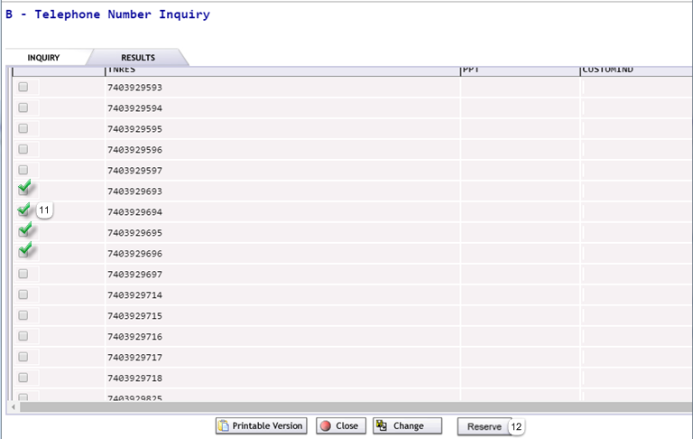  Select Number  Reserve  Note: If numbers are not reserved in 20 minutes, they will return to the number pool.

Cancel Reservation

Cancel Previously Reserved Numbers | From the Preorder Initiation screen:  - TXNUM – The system will pre-populate this field with a numeric value.  NOTE: For a cancellaton, the user cannot override this system generated TXNUM with the PON used during the original TN Reservation Pre-order. The system generated TXNUM or a new TXNUM meaningful to the user can be entered.  - TXTYP – Select B = Telephone Number Inquiry.  Populate the following fields:  TXACT - K = Cancels selection or reservation  - SELNUM = Selected Number/Reserved Number  - Submit  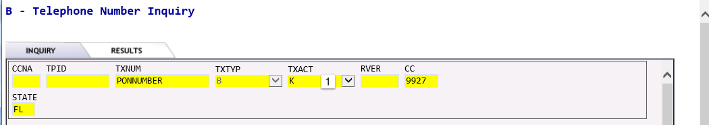  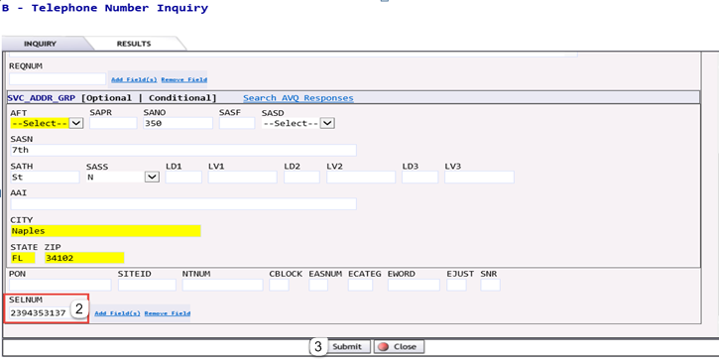  Result and response:  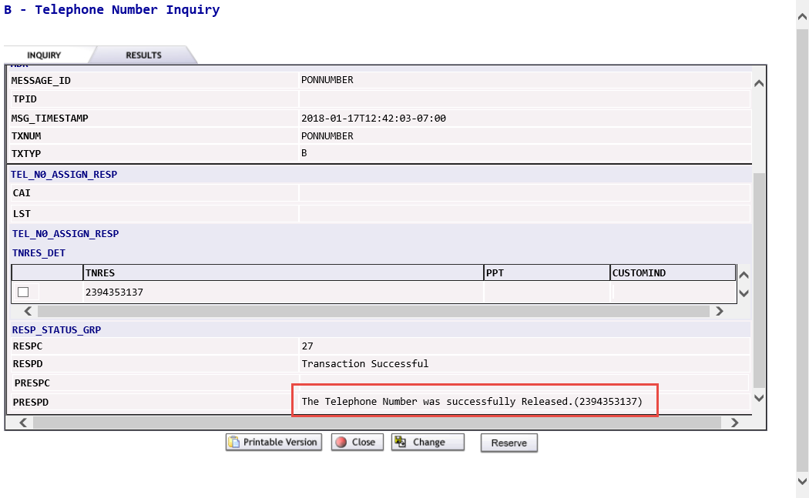

Customer Service Information

Customer Service Information Entry | After the Preorder Initiation screen populate the following fields.  TXACT - A = New Inquiry  STATE - two alpha characters (capital letters)  AGAUTH - Y  Select one:  AN = Account Number  WTN = Working Telephone Number  ECCKT = Exchange Company Circuit ID  Note: Do not use spaces or dashes  CSR Date (Current of future date)  Note: If a future date is entered and there are pending orders against the WTN or ECCKT, the activity specific to those orders will be applied against the current CSR and the result of the merged data will be displayed. This functionality is referred to as a Virtual CSR (VCSR) which will be identified with new fields on the response.  Submit

Customer Service Information Entry, cont. | 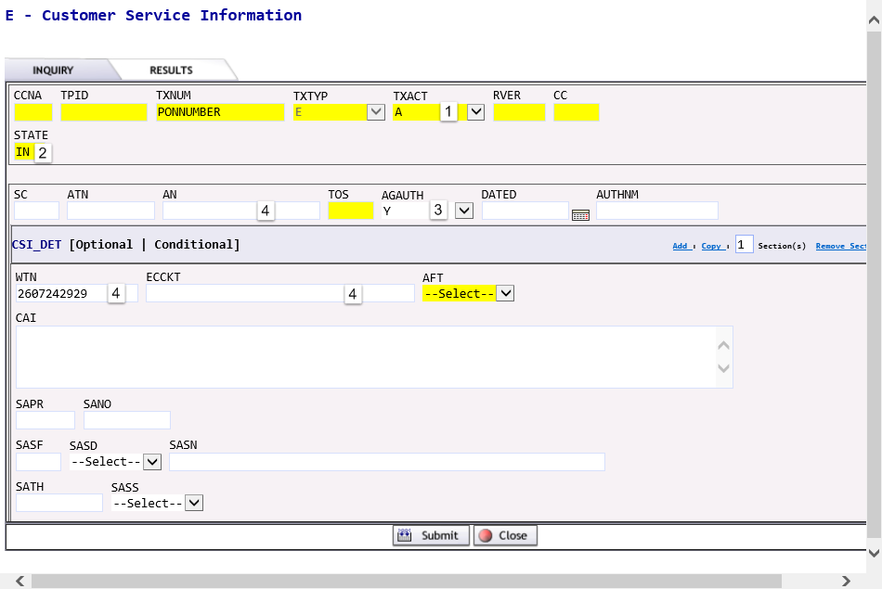  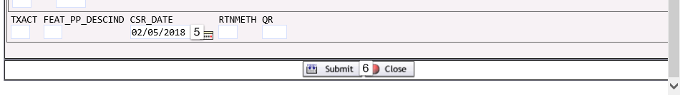

Customer Service Information Resuts, cont. | Results and responses:  WTN  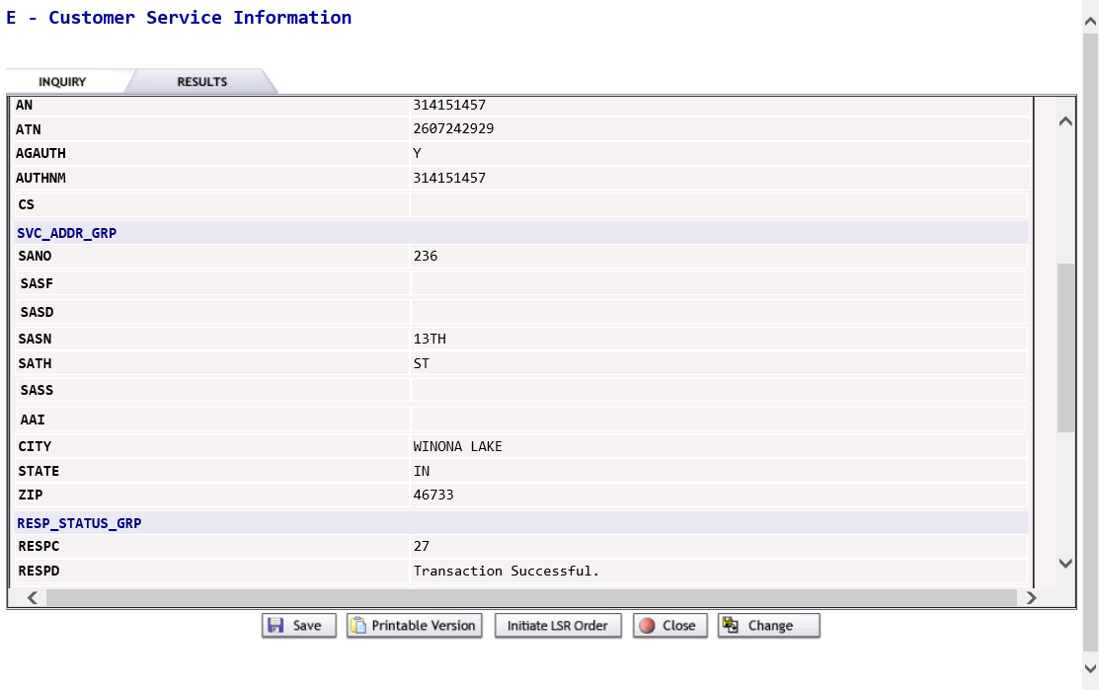  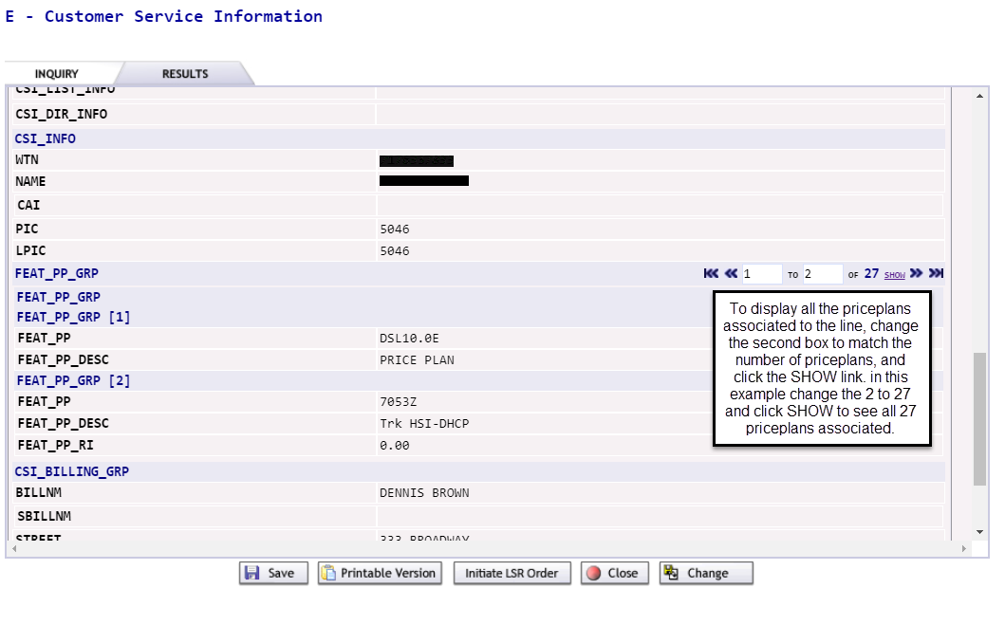  NOTE: May find it easier to view all data from Printable Version.  - Able to Save / Print / Initiate LSR Order / Close / Change the inquiry.

Customer Service Information Results, cont. | Results and responses, cont.:  CSR Date  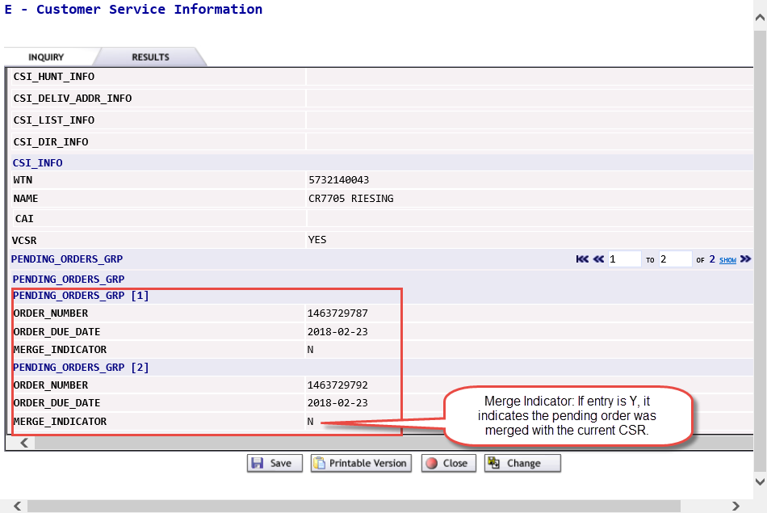  - VCSR – If populated with YES, inidicates there is pending order activity for the time up to the CSR DATE entered. The following fields will be populated.  - PENDING ORDERS GRP – This group of fields may repeat depending on the number of orders pending against this CSR.  - ORDER NUMBER – This entry represents the service order number of the pending order.  - ORDER DUE DATE – This entry represents the due date of the pending order.  - MERGE INDICATOR – If this entry is Y, it indicates the pending order(s) was merged with the current CSR and the detail provided is a result of the merged order(s).  NOTE: May find it easier to view all data from Printable Version.  - Able to Save / Print / Initiate LSR Order / Close / Change the inquiry.

Loop Qualification

Loop Qualification Overview | Loop qualifications serve to compile and filter loop network data for specific wholesale products. Loop qualification can be performed with:  - A validated address or working Brightspeed TN for Resold Broadband Service.  - A validated address or Brightspeed TN with or without NC/NCI codes for Unbundled ADSL loop qualification in a future release.  Loop Qual provides the following elements:  - Technology (ATM, ADSL, VDSL)  - Qualifying speeds  Loop Data provides the following elements:  - LOOPSTAT = Loop Status (Qualified, Not Qualified)  - LST = Local Service Termination (6 character CLLI)  - LLT = Loop Length Type (Actual, Estimated, Electrical)  - ELL = Equivalent Loop Length  - ECCKT = Exchange Company Circuit ID  - PGRES = Pair Gain Presence (Actual, Estimated)  - F1LPCP = F1 Loop Composition (Coaxial, Copper, Fiber)  - F2LPCP = F2 Loop Composition (Coaxial, Copper, Fiber)  - LCQ = Load Coil Quantity  - BTQ = Bridged Tap Quantity  - WTN = Working TN  - GA = Gauge (diameter of cable)  - LU = Length Unit (FT, KFT, KM, MI)  - LLG = Loop Length by Gauge  - LL = Loop Length

Loop Qualification Entry, cont. | After the Preorder Initiation screen populate the following fields.  TXACT - A = New Inquiry  STATE – two alpha characters (capital letters)  MS = Select A  - A = Resale  - B = Unbundled (Available in future release)  - Select One:  WTN (Provides loop qual and loop data information)  SVC_ADDR_GRP - address detail (Provides only loop qual information)  - SANO = Service Address Number  - SASN = Service Address Street Name  - SATH = Service Address Street Type  - CITY  - STATE (two alpha characters – upper case)  - ZIP  - Submit

Loop Qualification Results, cont. | Loop Qualification Inquiry with MS = A (Resale) by Address  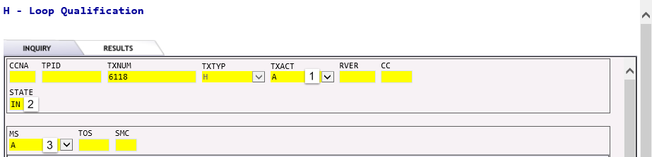  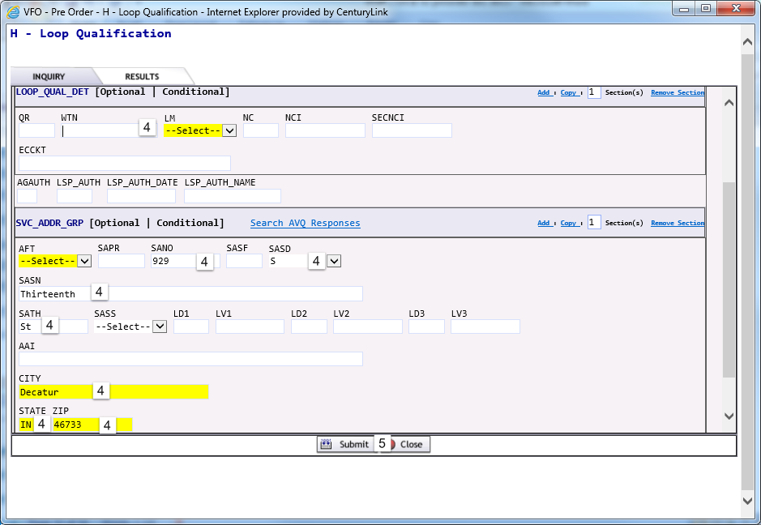  Result:  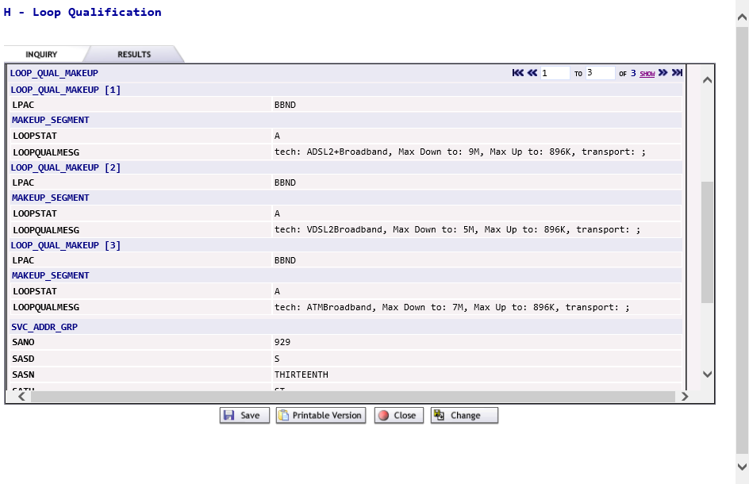  NOTE: May find it easier to view all data from Printable Version.  - Able to Save / Print / Close / Change the inquiry.

Loop Qualification Results, cont. | Result, cont.:  Loop Qualification Inquiry with MS = A (Resale) by Telephone Number  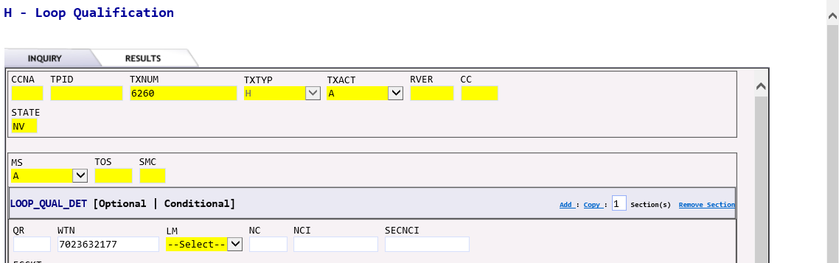  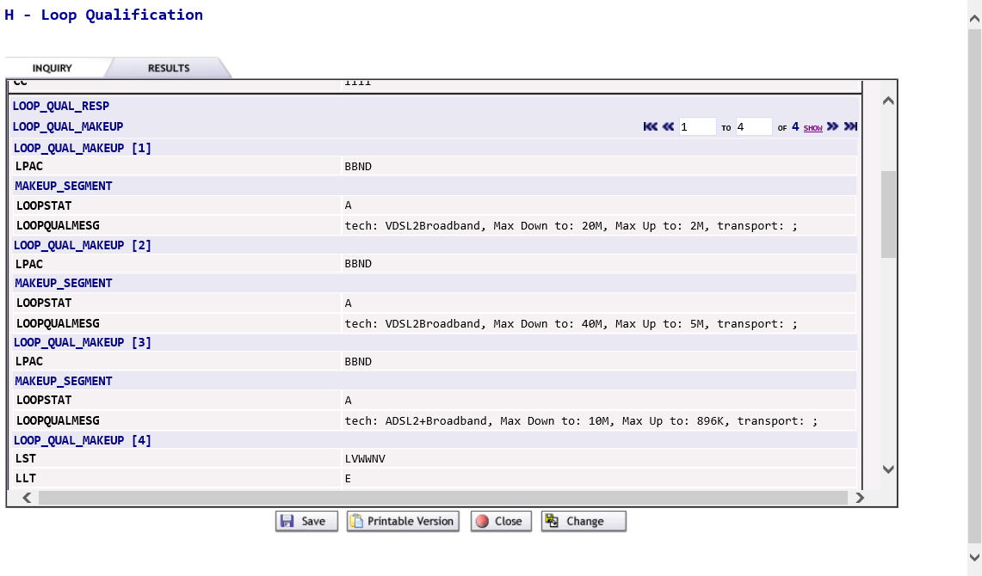  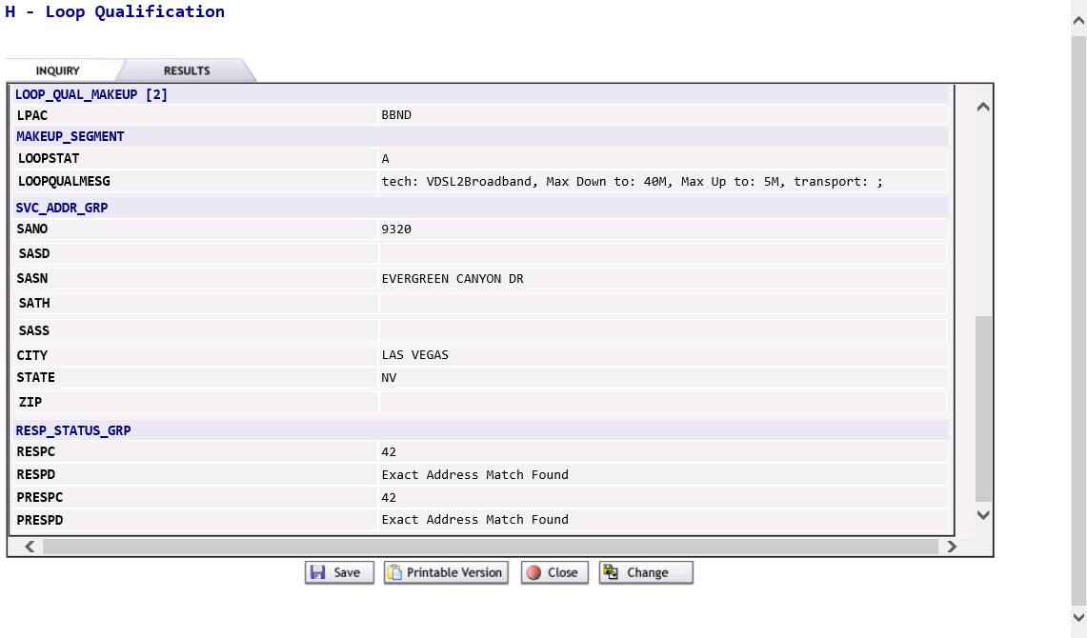  NOTE: May find it easier to view all data from Printable Version.  - Able to Save / Print / Close / Change the inquiry.

Raw Loop Data

Raw Loop Data Entry | This Pre-Order function retrieves Raw Loop Data by segments and sub-segments.  After the Preorder Initiation screen populate the following fields.  TXACT - A = New Inquiry  STATE – two alpha characters (capital letters)  - TNADDRCKTIND = Telephone Number, Address, Circuit Indicator  Options:  - T = Telephone Number  - A = Address  - C = Circuit  - Select one:  WTN - Selecting the Add Field link, will add additional WTN fields based on the number requested in the Add Field elements box or selecting additional Add Field links.  NOTE: WTNs can be for different end users and different addresses.  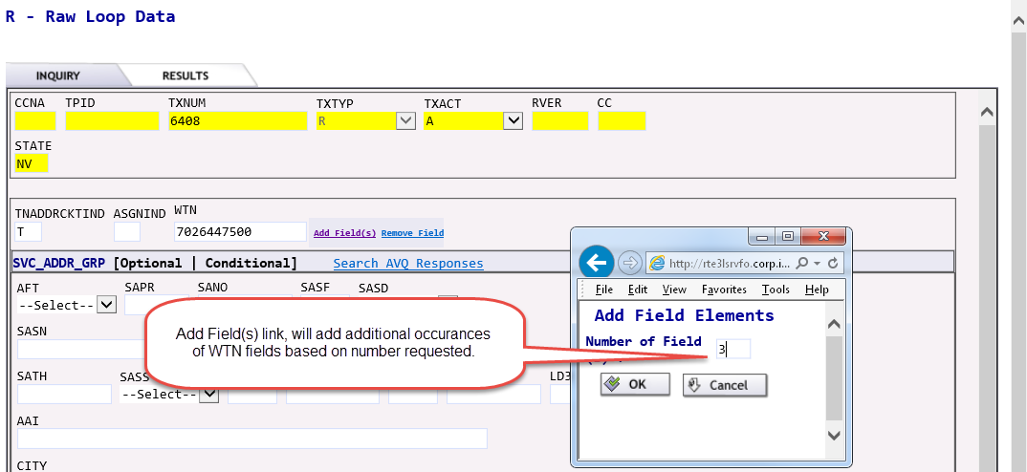

Raw Loop Data, cont. | Multiple WTN fields added from the Add Field Element box  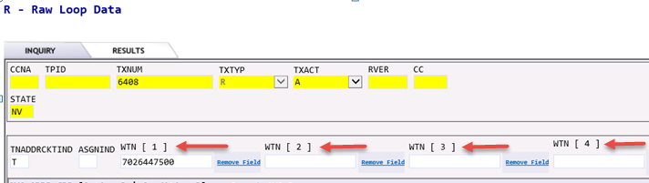  To remove WTN fields click the Remove Field(s) link.  SVC ADDR GRP – address detail (select this option when searching by assigned or unassigned facilities.)  - SANO = Service Address Number  - SASN = Service Address Street Name  - SATH = Service Address Street Type  - CITY  - STATE (two alpha characters – upper case)  - ZIP  Note: Additional address detail may be populated if applicable. For detail information on the additional fields, see Service Address Group section.  When searching by address, the ASGNIND field must be populated. Identifies makeup for assigned services or spare services.  Options:  - A = Assigned  - U = Unassigned or spare  NOTE: Unassigned or spare facilities searches will be available in a future release.  ECCKT = Exchange Company Circuit ID  When searching by circuit, the LSO (Local Service Office) field must be populated. Enter the primary NPA/NXX associated to the ECCKT.  - Submit  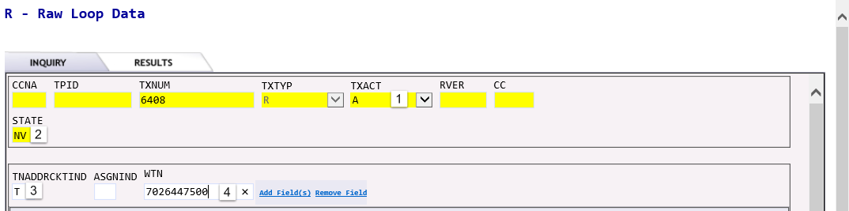

Raw Loop Data Results, cont. | Results and responses:  Raw Loop Data Inquiry by Telephone Number Results  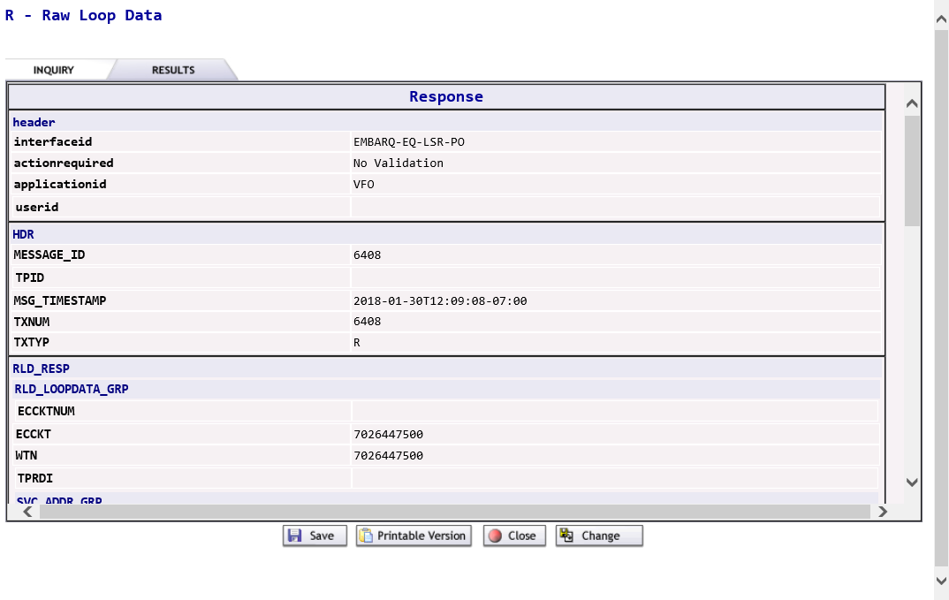  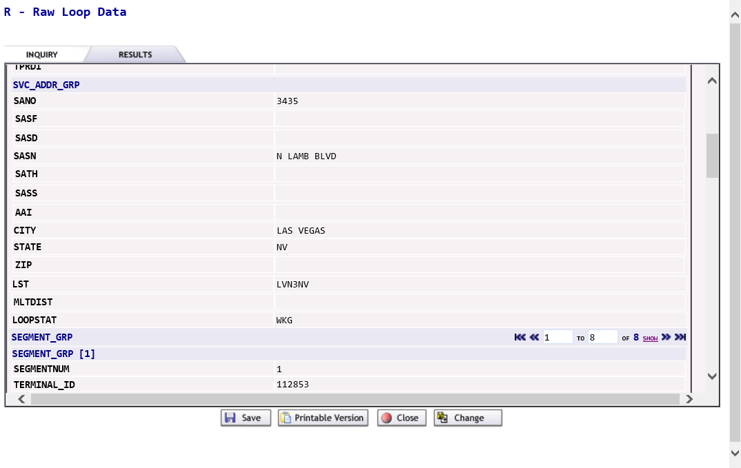  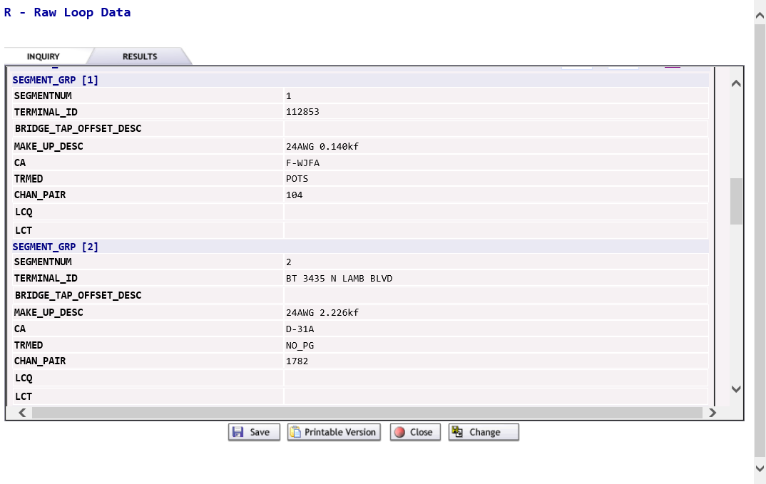

Raw Loop Data Results, cont. | Results and responses, cont.:  Raw Loop Data Inquiry by Telephone Number Results, cont.  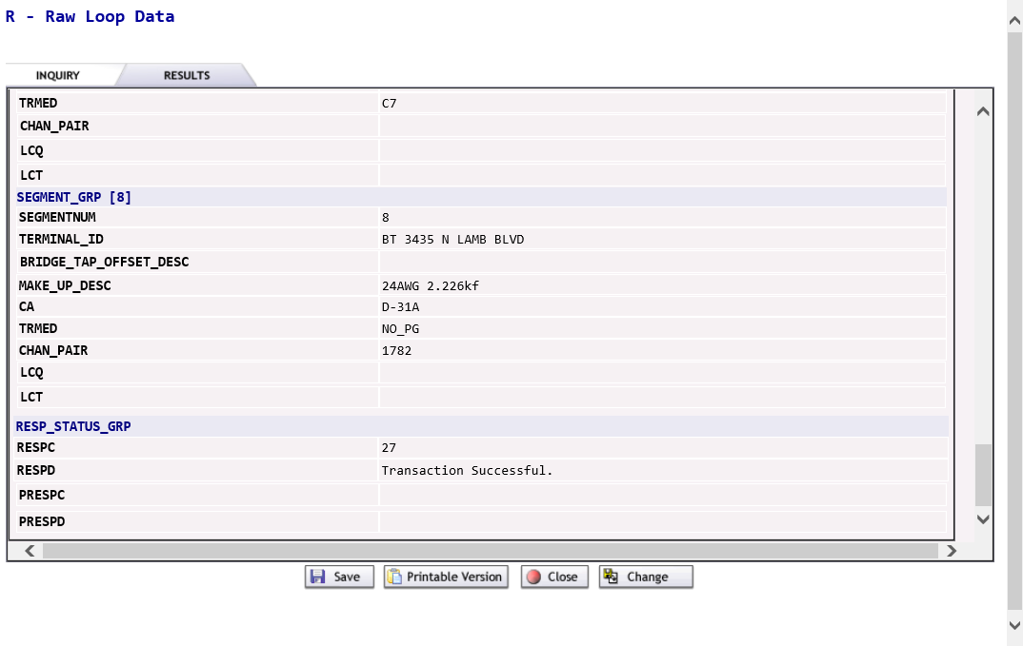  NOTE: May find it easier to view all data from Printable Version.  - Able to Save / Print / Close / Change the inquiry.  Raw Loop Data Inquiry by Service Address Results  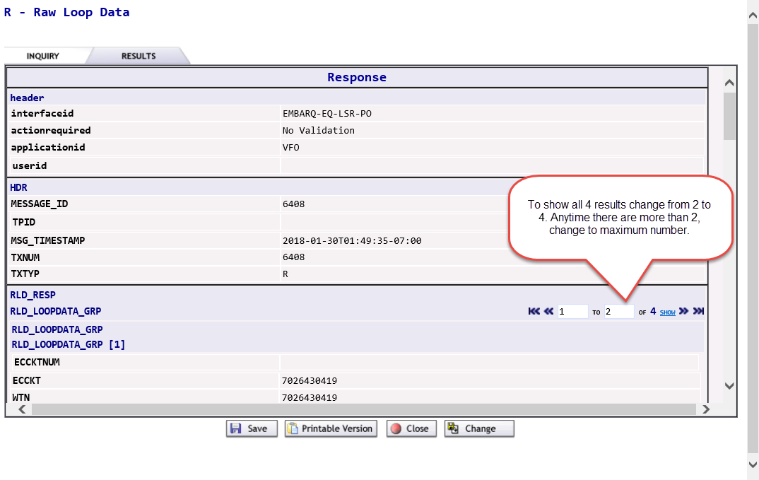

Raw Loop Data Results, cont. | Results and responses, cont.:  Raw Loop Data Inquiry by Service Address Results, cont.  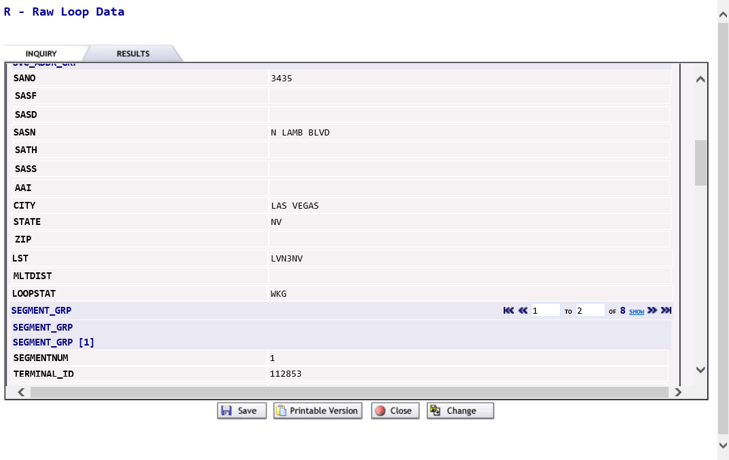  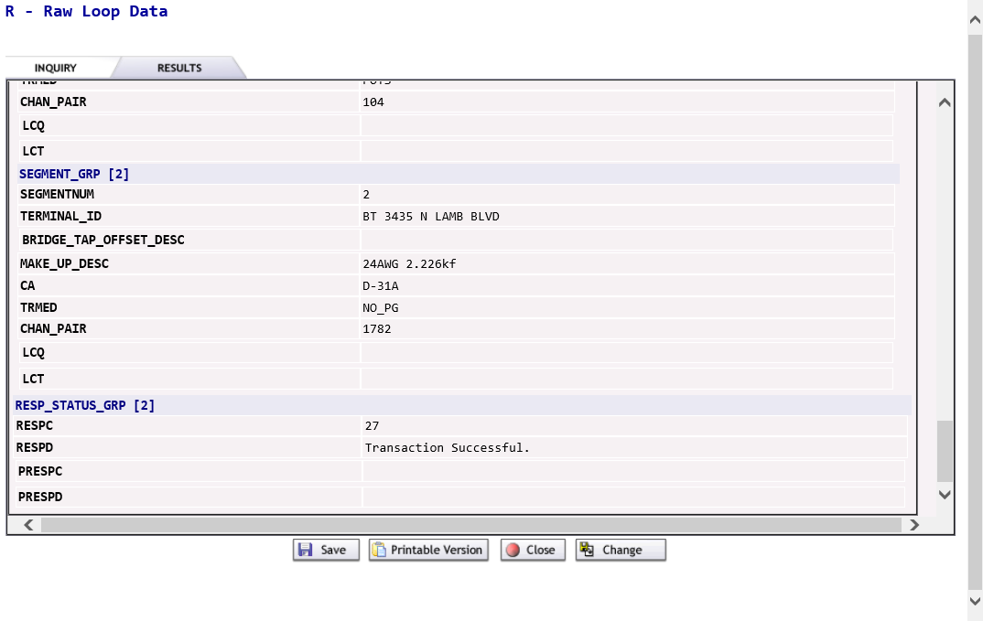  NOTE: May find it easier to view all data from Printable Version.  - Able to Save / Print / Close / Change the inquiry.

Raw Loop Data Results, cont. | Results and responses, cont.:  Raw Loop Data Inquiry by Circuit  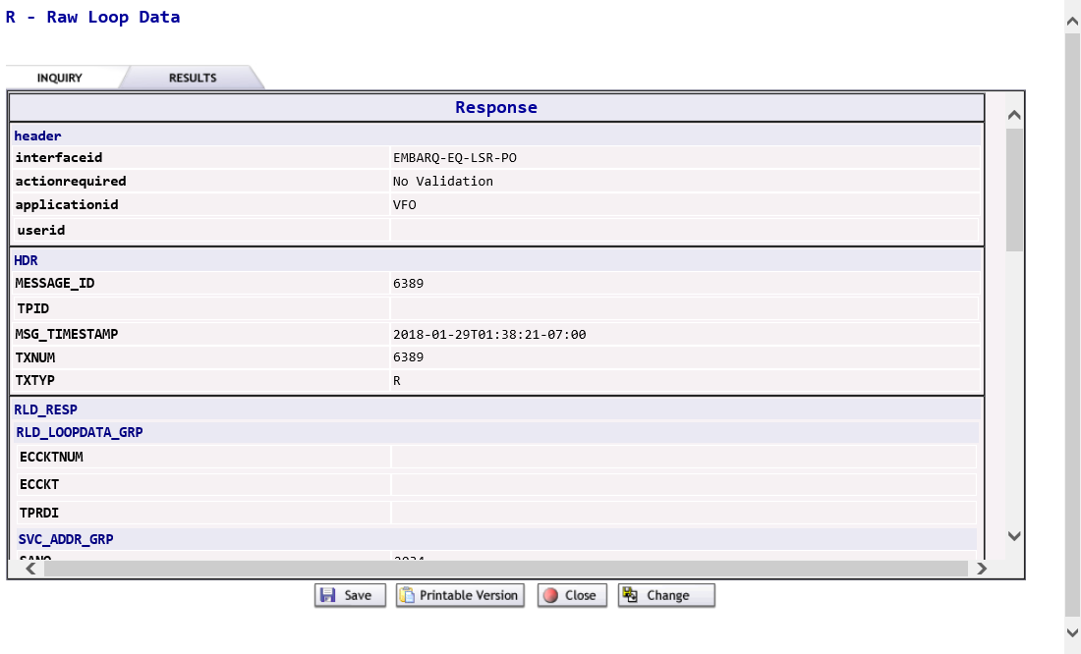  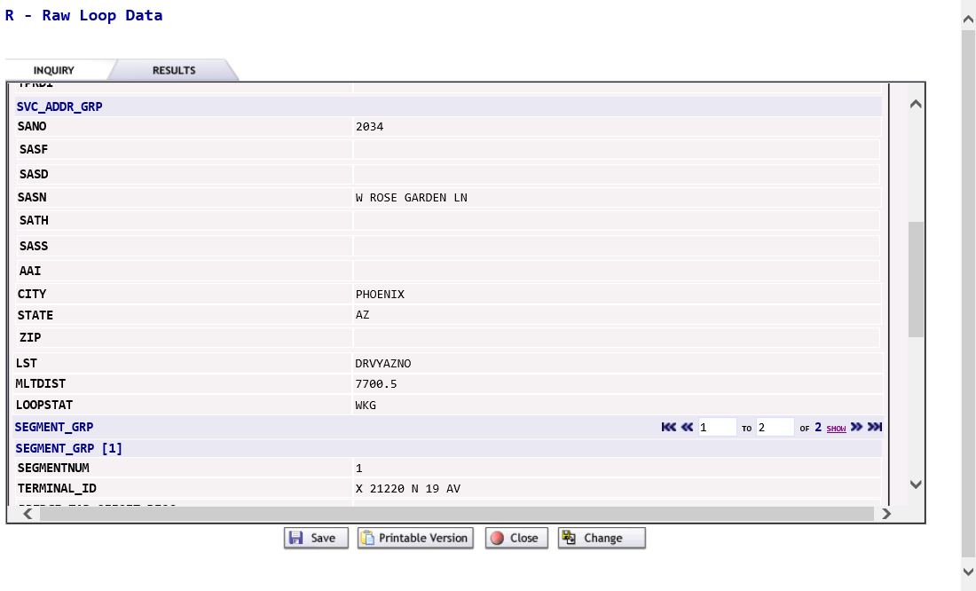

Raw Loop Data Results, cont. | Results and responses, cont.:  Raw Loop Data Inquiry by Circuit, cont.  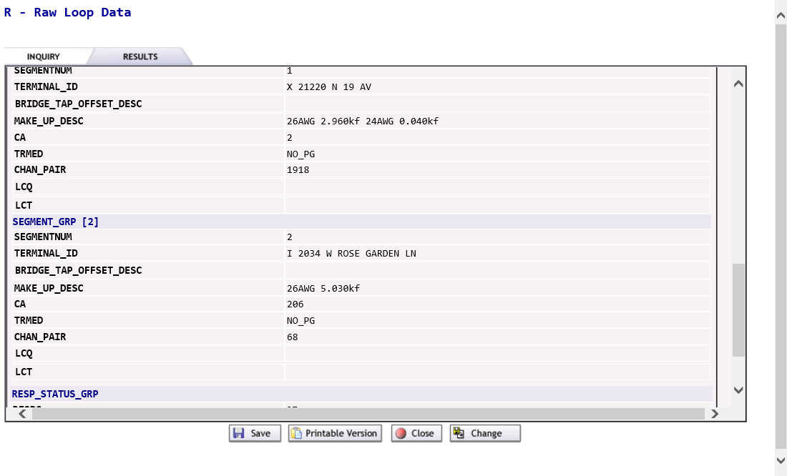  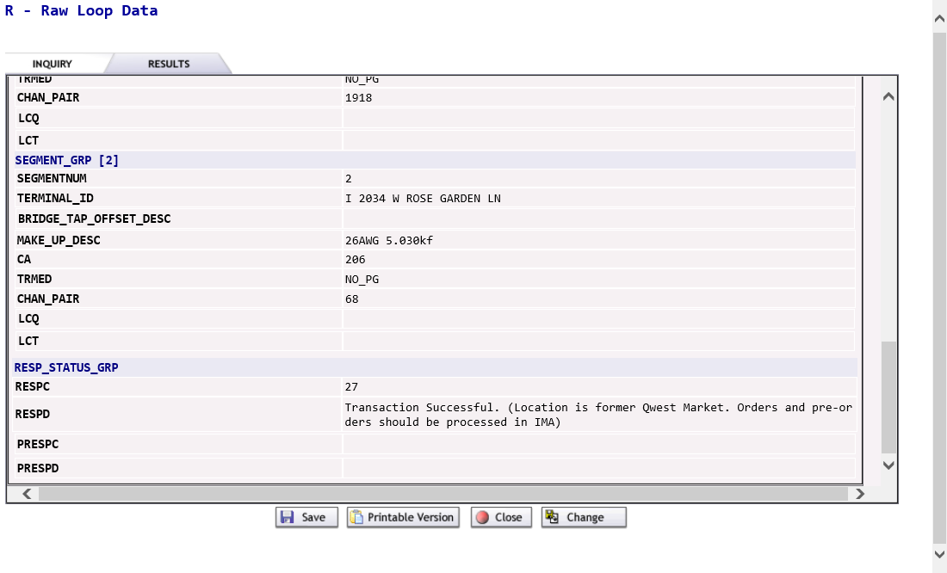  NOTE: May find it easier to view all data from Printable Version.  - Able to Save / Print / Close / Change the inquiry.

Listings for Telephone Number

Listings for Telephone Number Entry | After the Preorder Initiation screen populate the following fields.  TXACT - A = New Inquiry  - STATE – two alpha characters (capital letters)  - DIRNAME = Directory Name  - Enter the directory name  or  - Enter the YPPA code.  NOTE: If the directory name is entered, it has to be exact. YPPA Code or Directory Name can be retrieved from the External App Data for View Directory Name on the LSR Order Menu option on the Order List page.  STATE – two alpha characters (upper case)  CAPTION  - Enter the entire caption name  or  - Enter a partial caption name with one/two or more words, or a wild card character (%).  LTN = Listed Telephone Number (If not searching by DIRNAME, STATE or CAPTION)  - Submit

Listings for Telephone Number Results, cont. | 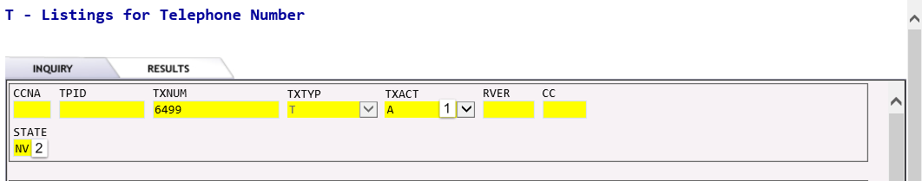  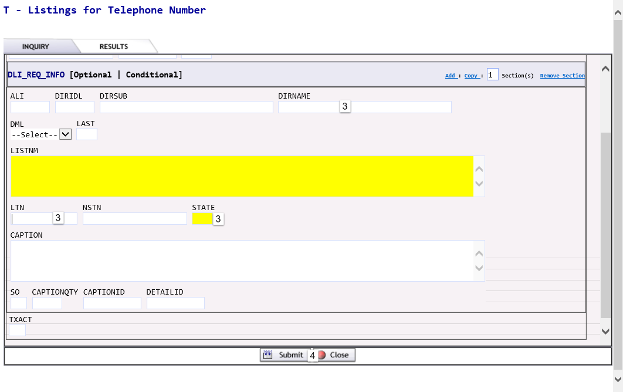  Results and responses:  Listings for Telephone Number by Caption  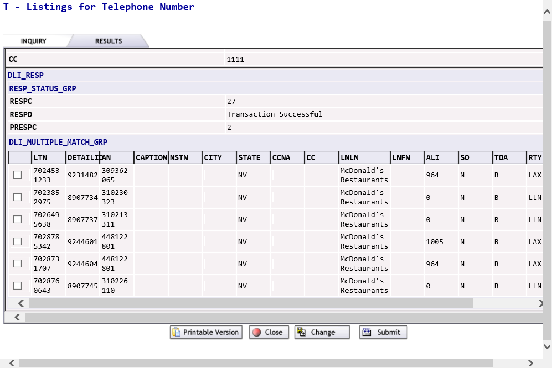  - Select the required caption name and click Submit to see the listing detail.  - Able to Save / Print / Close / Change the inquiry.

Listings for Telephone Number Results, cont. | Results and responses, cont.:  Listings for Telephone Number by LTN  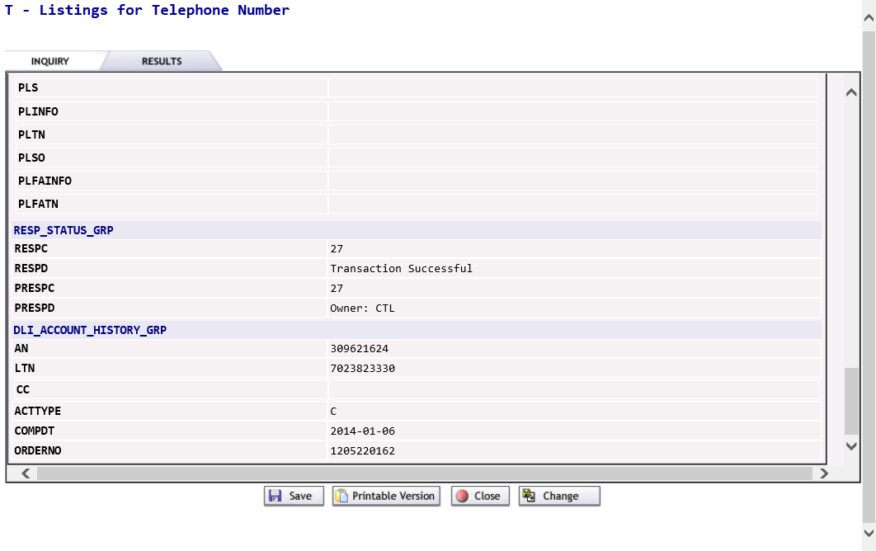  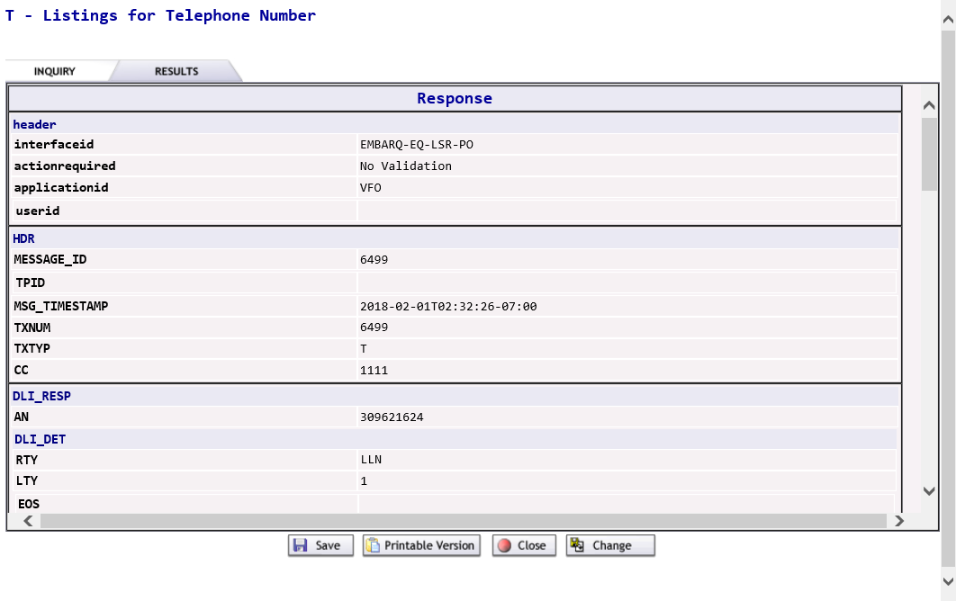  - Able to Save / Print / Close / Change the inquiry.

Save and Search

Save and Search Information | After the Preorder results are displayed this can be saved for future use. At the bottom of the Results screen, click Save. The message “Request and Response saved successfully” will appear at the top of the screen. Click the Close button to exit.  To initiate a search, return to the Preorder tab and select Search. Enter the search criteria in the fields at the top of the screen and click Go.  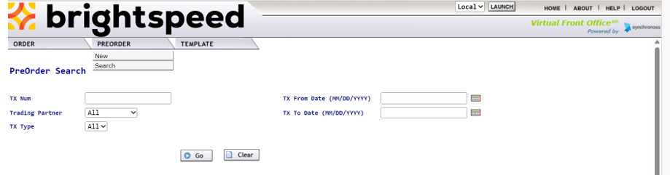  Preorder Search Fields  Field Name Field Function  TXNum Enter the Message ID that initial Inquiry and Response was saved. User can perform wildcard searches using the % symbol.  Trading Partner Select All or Embarq from the drop down box.  TX Type Select All from the drop down box.  Public Search If checked, it will search for all the saved preorders, from all users. If unchecked, it will limit the search to the users saved preorders.  TX From Date MM/DD/YYYY format. Enter the begin date in the MM/DD/YYYY format or click on the calendar to select the begin date for the date range.  TX To Date MM/DD/YYYY format. Enter the end date in the MM/DD/YYYY format or click on the calendar to select the end date for the date range search. If left blank, it will perform a search up to the current date.

Save and Search Information, cont. | Results will display under PreOrder List. At the bottom of the screen, the total number of saved results will display. Click on the number next to the Results Page or arrow to view the next ten results.  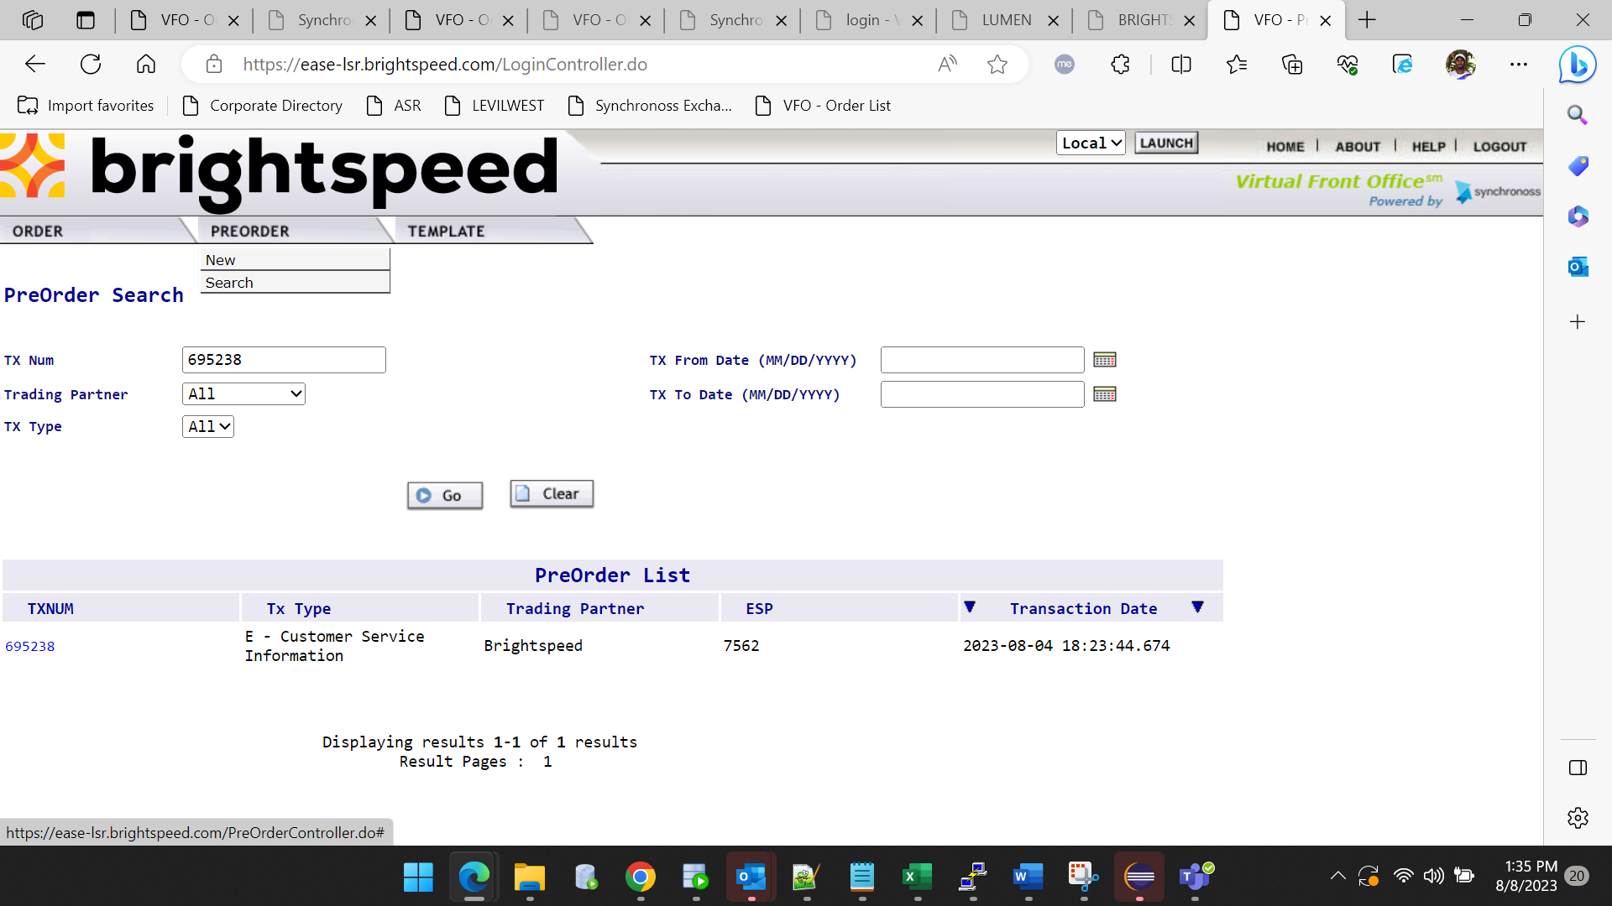  - Click Clear if wanting to remove populated criteria and begin a new search.

Save and Search Information, cont. | A Preorder search can be performed in an LSR. From the EU form:  - Search Pre-Order  - Click on selected TXNUM for saved preorder  - To transfer preorder data to LSR, click Prepopulate  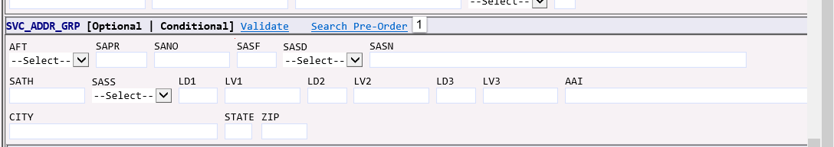  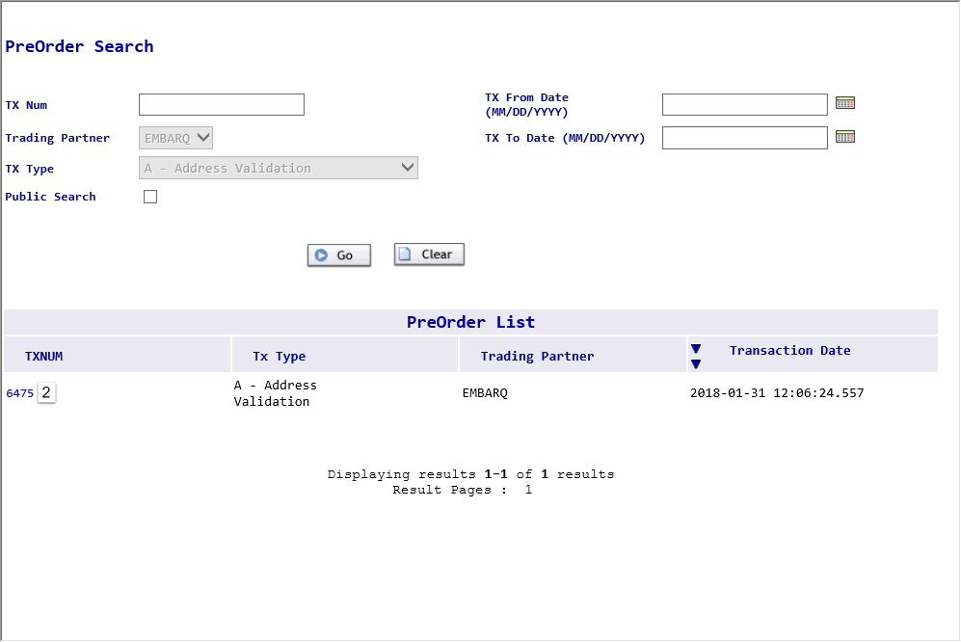

Save and Search Results, cont. | Preorder Search, cont.  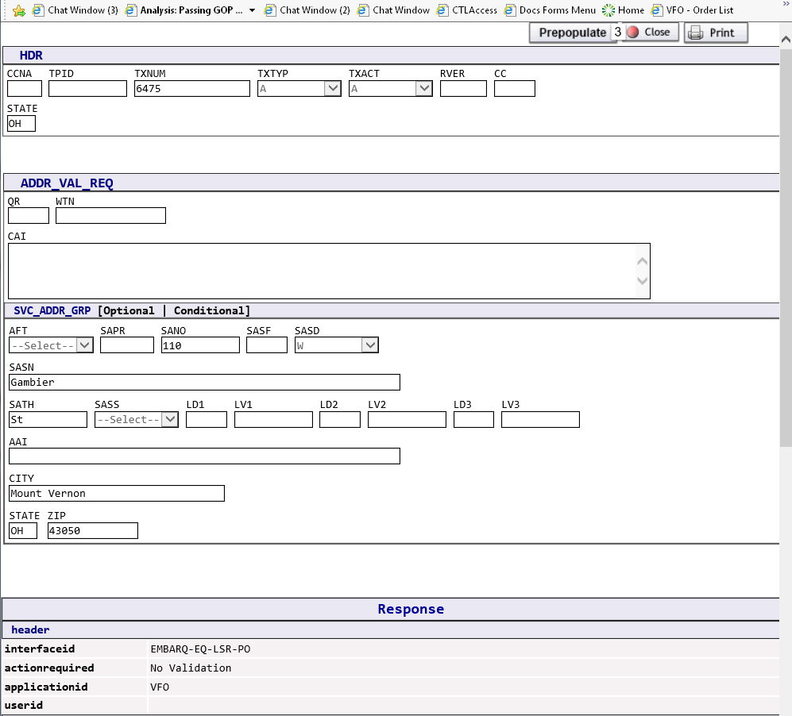  Results:  SVC ADDR GRP section from the EU form  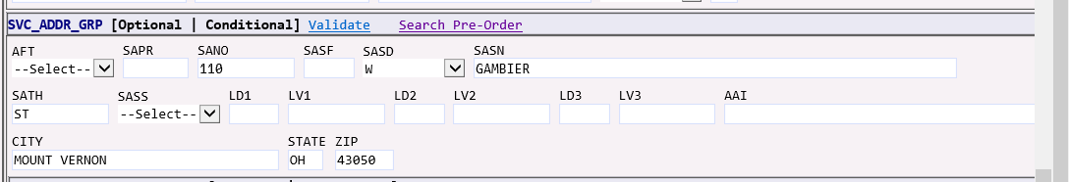  - A saved address can be retrieved and populated from this feature as well as telephone numbers being reserved.

Service Address Glossary

Service Address Field Definitions | There are certain fields required in the address section for any order that contains an address. The minimum entries in the address section are:  - SANO = House Number  - SASN = Street Name  - SATH = Street Type  - CITY  - STATE (must be in all capital letters)  - ZIP CODE  The following information is for other fields that could possibly be required depending on the address.  Address Field Definition  AAI (Additional Address Information) Identifies additional location information about the address.  AFT (Address Format Type) Identifies the format of the address being supplied. Valid Entries: A = Rural route and/or box number B = Unnumbered C = Provider Assigned house number D = Descriptive E = Provisioning Address  SAPR (Service Address Number Prefix) Identifies the prefix for the address number of the service address  SANO (Service Address Number) Identifies the number of the service address.  SASF (Service Address Number Suffix) Identifies the suffix for the address number of the service address number of the service  SASD (Service Address Street Directional Prefix) Identifies the street directional prefix for the service address—for example, N = North, S = South, E = East, W = West, etc.

Service Address Field Definitions, cont. | Address Field, cont. Definition, cont.  SASN (Service Address Street Name) Identifies the street name of the service address.  SATH (Service Address Street Type) Identifies the thoroughfare portion of the street name of the service address. For example: LN = Lane, BLVD = Boulevard, etc.  SASS (Service Address Street Directional Suffix) Identifies the street directional suffix for the service address—for example, N = North, S = South, E = East, W = West, etc. Note: The SASS is different than the SASD. The SASS is when the directional comes after the street name—for example, Main St West.  LD1, LD2, LD3 (Location Designators) Identifies additional specific information related to the address. Examples: unit, bldg, flr, box, room, apt, ste, complex and comm.  LV1, LV2, LV3 (Location Values) Identifies the value associated with corresponding designator  City Identifies the city, village or township.  State/Province Identifies the abbreviation for the state or province  Zip/Postal Code Identifies the ZIP code or the postal code. The Zip code should be valid for the state where the service address is located.  Note: Supplemental address information such as unit, bldg, etc. may be entered in either the LD/LV or the AAI fields.

Service Address Tips, cont. | Important Notes:  Abbreviations:  The Brightspeed Address Validation uses 911 addressing. Therefore, addresses in the database are reflective of the manner in which each individual city, state or community entered them. This will result in variances in the abbreviations. For example, Avenue may be found as AVE or AV.  Highways:  When validating addresses which are highways, you may want to try the following variations:  US XX (where XX = the highway number)  US Hwy XX  HWY XX  Numbered Streets:  Numbered streets are normally in the database using the numeral but they may also be spelled out. For example, Second Street may be 2, 2nd or Second. It is recommended that you first try your validation using just the number. For example: 2.

